# CS 255 System Design Document Template

This template lays out all the different sections that you need to complete for Project Two. Each section has guidance to prompt your thinking. You will need to continually reference the interview transcript as you work to make sure that you are addressing your client’s needs. There is no required length for the final document. Instead the goal is to complete each section based on what your client’s needs are. Remove this note when you are finished, and replace all bracketed text with the relevant information.

## UML Diagrams

### UML Use Case Diagram

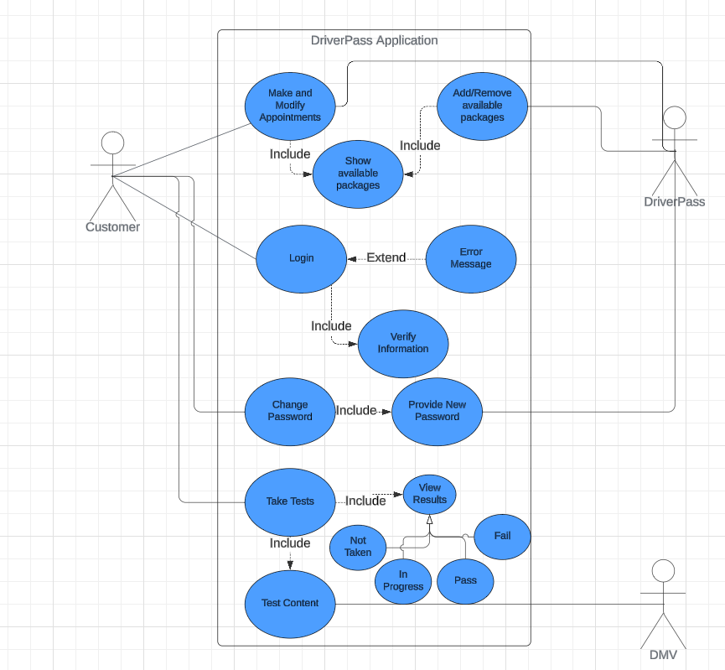

### UML Activity Diagrams (Appointment Creation and Login)

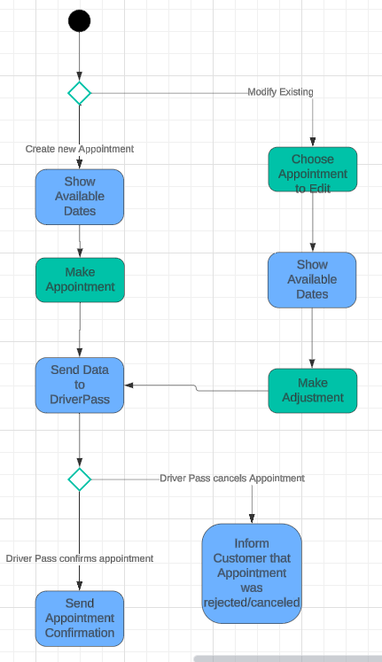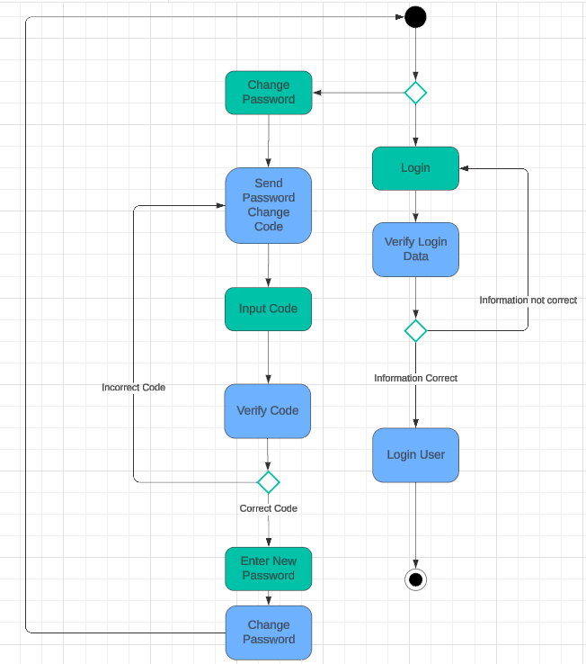

### UML Sequence Diagram (Appointment Creation)

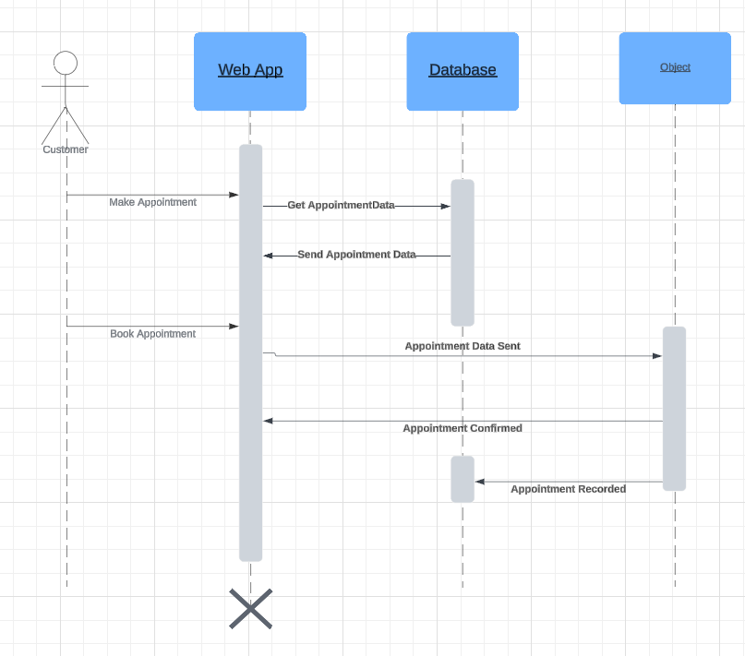

### UML Class Diagram

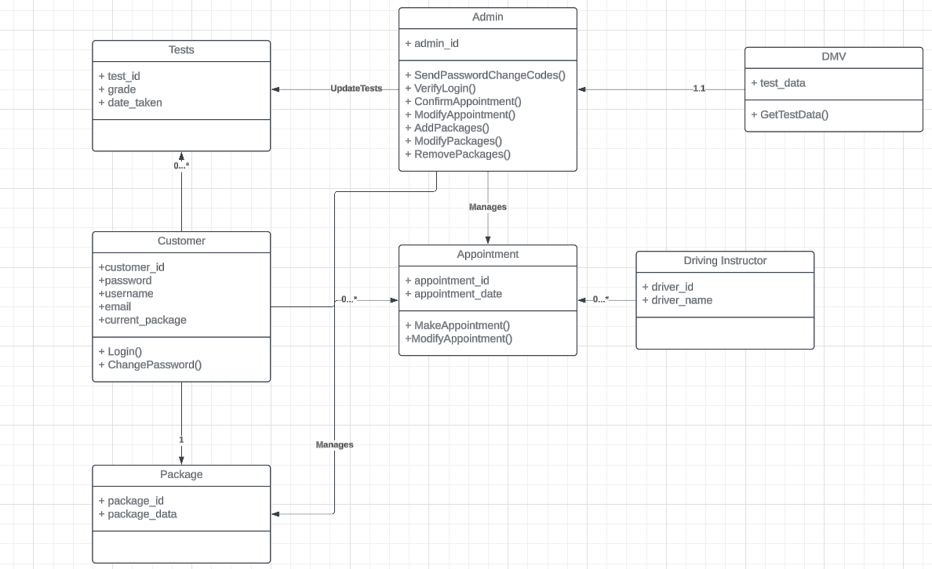

## Technical Requirements

As a base we will need to operate on a server of some kind. Customers are going to need to be able to access information wherever they need to and an online connection is required to communicate any appointment bookings or other information updates with DriverPass. In addition to this, a Database is needed to store user login data and track various other pieces of information including appointment information. The application will also need some sort of authentication system in place to verify user login information and allow them to change their passwords as needed. This system will also need some way to communicate with DMV servers to retrieve up-to-date rules and regulations for their tests.